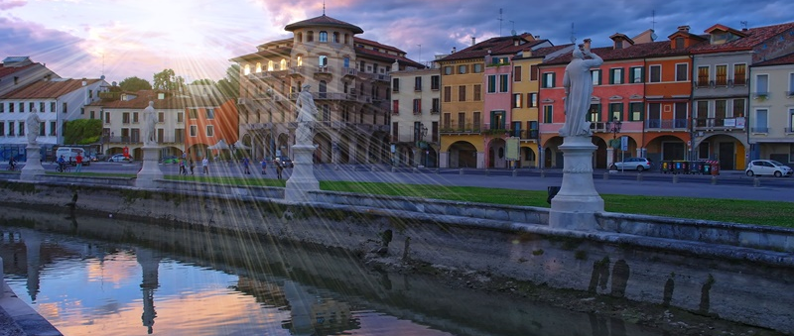
May, 9th-10th, 2024 | Padova, Italy
7th International Conference on
Rethinking Clusters, Ecosystems, and Places in Sustainability Transitions
[Insert title of the paper]
[Author(s) and affiliation(s). Corresponding author]
Conference theme: [Select your preference and delete the rest]
- The sustainability of places: industrial districts, clusters, regions, and ecosystems
- The transformative power of artificial intelligence, big data, block-chain, and Industry 4.0
- Mission-oriented industrial strategies and innovation policies
- Novel socio-technical regimes and sustainable innovation to address the just transition
- Culture, creativity, and tourism and their effects on sustainable development of places
- Innovation ecosystems and networks: agents’ positions, structure and dynamics
- Smart cities, urban development, peripheries and marginal areas
- Inequality mitigation, social innovation, and wellbeing: organizations, individuals, and communities
- Meeting the objectives of carbon neutrality: circular economy, zero waste, renewable energy and composting communities
- Exploring the dark side of innovation: the unexpected outcomes of the socio-technological progress
- History, path dependency, resilience, and evolutionary trajectories of territories
- The rise of hostility: how do populism, nationalism, conflicts, and terrorism change economies and places
- Global value chain and sustainable local development
- Regional development traps and catch-ups
- The flows of people and goods and their impact on entrepreneurship and innovation in places
- Competitiveness and innovation in industrial districts, clusters, regions, and ecosystems

